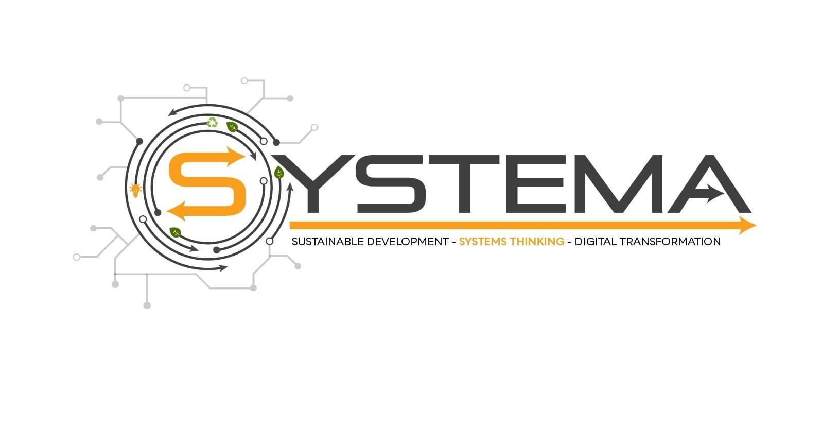
Manifestation of Interest Letter

To:
Dr. Eng. Stefano Armenia
President of SYDIC
System Dynamics Italian Chapter
Coordinator of the SYSTEMA project
From:
Name:
Role:
Organization:

Dear Eng. Armenia,
I hereby confirm that the organization I represen

acknowledges

The “SYSTEMA- Systems Thinking as a core competence for Sustainable Development and Digital Transformation” project, funded under the Erasmus+ Programme (2020-1-IT02-KA204-080082) as an important project in adult education, and
Expresses

Its willingness to participate in this initiative and become an external supporter of the project throughout its lifecycle. It is understood and mutually agreed that participation will happen on a voluntary basis and hence totally free, so no payments will be required and requested from the organization/institution signing this MOI and, likewise, no fees will be provided by the consortium partners.
In this perspective, we
Agrees to

- Support the dissemination of the project, by promoting the project outcomes and public events through our social media and networks, in line and complying with the dissemination actions taken by the project consortium

- Deal with respect and confidentiality to all the material and documents that will be received

- Provide the consortium with its official logo in order to be included in the project website, and on the other hand include the SYSTEMA official Logo in its website (if possible)

- Make its know-how and data in its possession available to the project consortium, especially in the case of familiarity with the topics covered by the project

- Send learners to training courses provided as part of the project by the consortium (if in line with its financial feasibility criteria)

- Identify other stakeholders that might be interested in participating in the project

- Consider the inclusion of the SYSTEMA educational module in its training courses as soon as the circumstances allow it

And also we,
Recognizes and accept, as stakeholder’s benefits, to

- take advantage of SYSTEMA training courses free of charge for its learners

- have all the results and deliverables of the project available

- be allowed to use the SYSTEMA educational module in its training courses even after the end of the project

Authorizes

the project coordinator to process data and information collected solely for the needs of the project during its duration and according to the rules of GDPR (General Data Protection Regulation E.U. 2016/679)
.

Full name:
Position:
Address:
Telephone:
Email:

Place, date The legal representative
……………… ………………….

